1.Functions of OS :

1. Security
2. Job Accounting
3. Error Detecting Aids
4. Control over system performance
5. Coordination between other applications softwares and users
6. Processor management
7. Device management
8. Memory management
9. File management

2. Memory of the process :

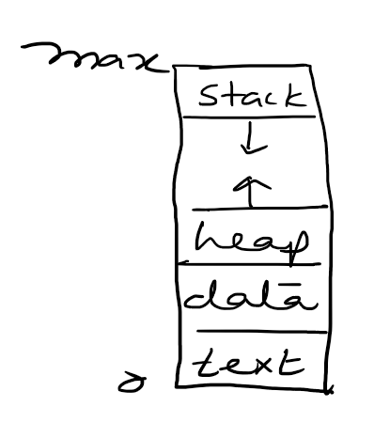

Subhradip Debnath  
Sec : A, Roll : 19  
date : 3/8/2020